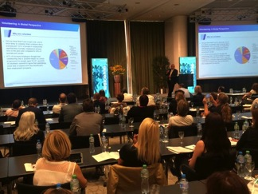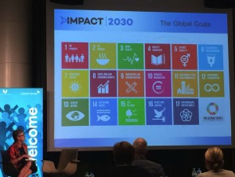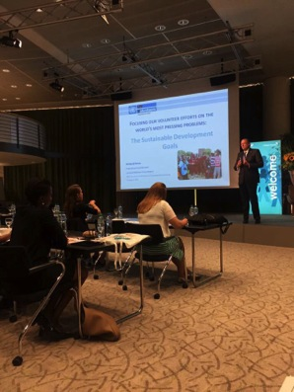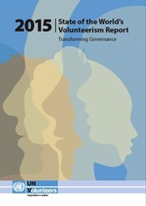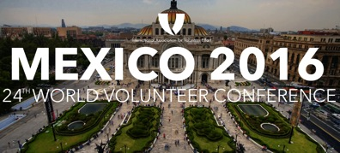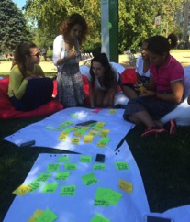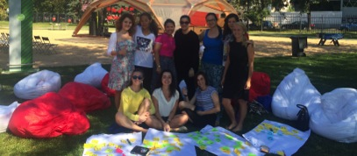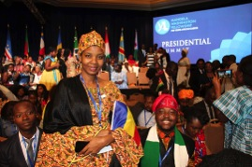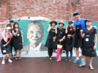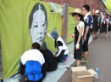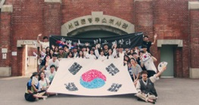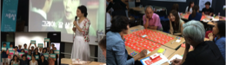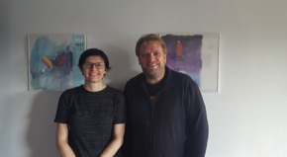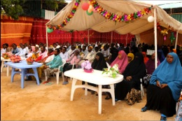

***“How much does it matter to me?”***

That was the question posed by Lord Michael Hastings, Global Head of Citizenship for KPMG International, to participants in the European Conference on Corporate Volunteering.

The question came at the end of a creative and inspiring presentation he had delivered about the challenges raised by the realities of the world that have led to the United Nations Sustainable Development Goals (SDGs).

His point was forceful. At the end of the day, each individual must ask what issues like poverty, injustice, environmental degradation, inequality, the growing forced migration of people seeking safety and on and on – what such issues mean to them and what they are willing to do about them.

“How much does it matter to ME – not how much does it matter to my employer, my government, my religious group, my neighbors? What will I do to create and support change?”

On August 31 and September 1, some 120 people from global companies and NGOs gathered at Seminarhotel Bocken, just outside Zurich, Switzerland for this first conference co-hosted by Credit Suisse and IAVE.

In his opening keynote speech, Richard Dictus, Executive Coordinator of United Nations Volunteers, posed the challenge that framed the entire conference: how will the business community respond to the SDGs? Will they commit to a clear, high priority focus on contributing to achieving them?

He emphasized the need for “co-creating” a new approach to development that takes into account institutional realities and potential benefits of collaboration within and across sectors.

His key “take home messages” were these:

* Integrate the SDGs into corporate social responsibility programs.
* Discover new spaces and open them up. Select the entry point most appropriate for you.
* Develop new partnerships and change the rules.
* Work from your corporate strengths (including skills based volunteering).
* Combine philanthropy (money) and volunteering (people).

IAVE also held a special pre-conference meeting for members of the Global Corporate Volunteer Council and other invited companies that focused on the state of health of corporate volunteering in Europe.

Members of the IAVE Board of Directors participating in the conference were Kylee Bates, World President who spoke at the opening plenary and moderated two forum sessions; Wendy Osborne and Eugen Baldas who each moderated a forum session.

The IAVE Secretariat team on site were Kathi Dennis, Lorrie Foster, Ramona Dragomir and Kenn Allen. Supporting from the Secretariat office was Jessica Han who had developed the conference website and conference materials.

The conference website soon will make available videos, PowerPoint presentations and other materials from the conference. Watch for an announcement of that.

**Lord Michael Hasting’s** (KPMG) plenary on “Changing the Way We Do Business: Building Our Impact, Demonstrating Our Value”

**Successful European Conference   
on Corporate Volunteering**

**News from IAVE**

* Successful European Conference on Corporate Volunteering
* Just One Word…
* An Overview of the State of the World Volunteer Report 2015 with Amanda Mukwashi
* Raaida at the IV International Forum of Young Professionals
* You’re Invited to IAVE’s 24th World Volunteer Conference in Mexico City!

**News from IAVE Members**

* Celebrating Volunteers in Chad
* Human Library for the 70th Anniversary of Independence Volunteering
* A Graduation Ceremony in Somalia in Honor of Volunteers and Volunteering
* A Report on Volunteering in Denmark
* Women’s Equality Day and Vision 2020
* Ford Inspires Tomorrow’s Leaders Today with New Global Grant, Innovative Employee Civic Leadership Program

In This Issue

September 2015

**E-IAVE**

Just One Word…

By Kylee Bates, IAVE World President

The word *volunteer* appears just once in the 15,000+ word draft outcome document for the UN Summit to adopt the post-2105 Development Agenda that world leaders will convene in New York to adopt later this month, but appear it does.

Paragraph 45 of *Transforming our World: the 2030 Agenda for Sustainable Development* recognises that implementation of the commitments intended to achieve the proposed 17 Sustainable Development Goals will require governments to work with, and involve volunteers. It says “We acknowledge also the essential role of national parliaments through their enactment of legislation and adoption of budgets and their role in ensuring accountability for the effective implementation of our commitments. Governments and public institutions will also work closely on implementation with regional and local authorities, sub-regional institutions, international institutions, academia, philanthropic organisations, volunteer groups and others.”

This is vital recognition for volunteers and volunteering and something for which IAVE has advocated over a number of years, gaining formal expression in the IAVE Board of Director’s ‘Call to Action’ made at the 2014 World Volunteer Conference.

Framed around the 5 P’s of People, Planet, Prosperity, Peace and Partnership this people-centred agenda articulates 17 goals that will drive development focus over the next 15 years, and in which volunteers in every region of the world are actively engaged in the pursuit of.

There is also growing recognition that volunteers will be a vital means by which collaboration between the non-government and private sectors will be fostered to support the implementation of key development initiatives. It was a topic given loud voice at the recent European Corporate Volunteering Conference in Zurich held in partnership between Credit Suisse and IAVE with both conference keynote speakers. Richard Dictus, Executive Co-ordinator of United Nations Volunteers and Dr Michael Hastings, Lord Hastings of Scarisbrick CBE, Global Head of Corporate Citizenship at KPMG International each spoke to the opportunities that the proposed Sustainable Development Goals provide. While a number of companies spoke with conviction about how they are already beginning to align their corporate volunteering activities to impact the achievement of the SDGs.

*Volunteer* is just one word in the draft outcome document on which the UN General Assembly will vote on 25 September but it represents the impact that one billion volunteers worldwide will make on transforming our world through the achievement of the Sustainable Development Goals over the next 15 years.

<http://www.un.org/ga/search/view_doc.asp?symbol=A/69/L.85&Lang=E>

**Sue Stephenson** (Ritz Carlton Hotel Company) sharing the 17 global goals of Impact 2030.

**Richard Dictus’s** (UNV) plenary on “Focusing Our Volunteer Efforts on the World’s Most Pressing Problems: The Sustainable Development Goals

**An Overview of the State of the World Volunteer Report 2015 with Amanda Mukwashi**

The [**State of the World’s Volunteerism Report 2015**](http://www.volunteeractioncounts.org/en/swvr-2015.html) (SWVR 2015) is the first global review of the power of volunteer voices to help improve the way people are governed. Drawing on evidence from countries all over the world, the report shows how ordinary people are volunteering their time, energies and skills to improve the way they are governed and engaged at local, national and global levels. **Join us next week on our webinar overviewing findings within the report, presented by Amanda Mukwashi of UNV.**Amanda is the Chief of Volunteer Knowledge and Innovation at United Nations Volunteers. She was the Team Lead for the development of the SWVR 2015, which was released this past June. Amanda will be reviewing the key points of the report and will be available for a Q & A session with the audience.

**DATE: September 8th, 2015  
TIME: 5:00 PM Central European Summer Time**[**SIGN UP TO ATTEND**](https://attendee.gotowebinar.com/register/1831518459942076674)

Raaida at the IV International Forum of Young Professionals

**When:** November 4-10, 2016 (Nov. 4-6, Youth Conference)  
**Where:** Mexico City, Mexico

Join us in November 2016 for our 24th World Volunteer Conference in Mexico City, Mexico, hosted by Centro Mexicano para la Filantropía A.C. (CEMEFI).

The World Volunteer Conference invites volunteer leaders from all different sectors to convene, develop their network and skills, and learn about emerging trends and best practices in global volunteering.

Preceding to the World Volunteer Conference, CEMEFI will also be hosting the IAVE World Youth Volunteer Conference from November 4-6th. Youth volunteers between the ages of 16-25 are invited to attend. This conference aims to further promote youth volunteering and to provide a space for young people to challenge and inform one another.

**Stay updated at** [**iave.org/mexico2016**](https://www.iave.org/mexico2016)

Join Us at IAVE’s 2016 World Volunteer Conference & World Youth Volunteer Conference in Mexico City!

The Project Manager of our Youth Strategy, Raaida Mannaa, was invited to represent IAVE in the IV International Forum of Young Professionals, organized by the Moscow Youth Multifunctional Center, established by Moscow Department of Culture. The event, that took place on August 19- 22 in Moscow, Russia, consisted of a series of more than 150 interactive cultural and educational activities in libraries, museums, parks and public spaces, with more than 100.000 overall visitors.

Raaida was part of the group of international speakers invited from countries like India, Armenia, China, Germany, Lithuania and Moldova. She shared the work of IAVE worldwide, -particularly with youth-, in a special activity to share volunteering experiences, and conducted workshops for youth volunteer managers of different NGOs and Government Agencies in Moscow.

**Celebrating Volunteers in Chad  
By Djibrine Souleymane Amlkher,** Founder & President, Nirvana Organization for Women and Youth Empowerment in Africa, IAVE Member, Chad

Volunteering is growing in popularity in Chad, especially amongst young people within the nonprofit sector. Responding to the increasing presence of volunteering in the country, two nonprofit organizations, Collective Associations for Citizenship and Safeguarding Democratic Achievement in Chad (COCSAD) and Nirvana Organization for women and Youth empowerment in Africa, will be hosting an event to celebrate volunteering in Chad before the end of this year.

These nonprofits led by the young men and women of Chad have dedicated their time and effort to serve their community. They focus on improving several different sectors in their community including education, health, human rights, politics, agriculture, culture and sports. Each month they organize a service event, mobilizing over 100 young people to devote their time to volunteering.

This year all their hard work and efforts were recognized on a global scale. Nirvana’s Founder and President, and active IAVE member, Djibrine Souleymane Amalkher was invited to participate in the Young African Leaders Initiative (YALI) in the U.S. She also had the opportunity to meet President Barack Obama in Washington, DC this past August. The President commended them all on their tremendous work and asked other young people to follow their example. Each of the participants of YALI was presented with a certificate of completion, signed by President Obama himself. It was truly a blessing brought on by the volunteer work these men and women do daily to improve the lives within their communities.

The event hosted by COCSAD and Nirvana is expected to be a wonderful opportunity for Chadian volunteers to be heard and celebrated. It will also be a great chance to further expand their relationship with the government and provide recommendations to further expand and support volunteering in Chad.

News from IAVE Members

Human Library for the 70th Anniversary of Independence: Fighters for National Independence and Volunteers Meet as Citizens

By Yoonae Park, CEO, Seoul Volunteer Center, IAVE Regional Representative, Asia-Pacific

Seoul Volunteer Center, in commemoration of Korea’s 70th anniversary of independence, organized a special “Human Library” lecture series named “Fighters for National Independence and Volunteers Met as Citizens” which was open to the public.

This program is one of the main projects Seoul Volunteer Center concentrates on through its Online Volunteering Platform, V-World, to spread its core value: making a better world through small activities everyday. This program allows individuals to meet and hear stories from those who have fought for independence in the past and the active volunteers in Korea. This gives individuals the chance to brainstorm and engage with one another, as well as the opportunity to collaborate in organizing socially responsible activities. This is the type of the civic consciousness needed in today’s society.

“Fighters for National Independence and Volunteers Met as Citizens” include 7 lectures and was divided in 3 parts by topic. The first part focused on citizens in the past, the second was about citizens in the present, and the third about citizens of the future. Here are the details:

In August 2015, the Somali Center for Voluntary Activities (SOCVA) organized a graduation ceremony in the capital city of Mogadishu for primary and secondary graduates of Jowhar al-Islam, one of the schools run by SOCVA. The ceremony was largely a tribute to volunteers and volunteering and was attended by guests from different sectors of the society including those representing schools, universities, telecommunication companies, banks and others.

Two of SOCVA’s objectives are:

1. The construction of schools for the development of education in the country.
2. Ensuring that the children of poor families can attend school.

Through the efforts of its volunteers, SOCVA has organized and advocated for efforts to construct five rooms for Jowhar al-Islam primary and secondary school which has two shifts: morning and afternoon. Volunteers collect all the supplies and equipment needed for the school and reduce the costs of the school as much as they can through volunteers. None of the staff of the school, whether they are administrators or teachers, get salaries, but only get incentives provided by SOCVA.

SOCVA volunteers have also succeeded to collect donations from companies to cover the costs of the graduation ceremony, as well as to reward students with high marks (61 students) and to grant scholarships for graduates with especially high marks (51) to further their education within Sudan or abroad.

In addition, the students themselves volunteer. They serve as peer tutors helping other students with their studies, and as peer mediators helping settle arguments and disputes among students, organize fundraising at school, and coach and manage sport teams.

At the graduation ceremony, Mr.Hussein Egal Ali, chairman of the school, welcomed those attending, thanked SOCVA and the supporting companies who shared in encouraging the graduates, and expressed how voluntary activities are necessary for educational improvement in Somalia.

As the deputy head of SOCVA, Mr. Mohamed Abdirisak noted that the ceremony had two primary objectives: The motivation and rewarding of graduating students and the promotion and recognition of voluntary activities, so important for the rebuilding of Somalia.

Mr. Hussein Mohamoud Shidane, who talked in the ceremony on behalf of other parents, thanked both SOCVA and the administrators and teachers. He reminded those attending that the ceremony’s theme was “Do work voluntarily” which fits well with the approach of SOCVA to make education accessible to poor families through its voluntary activities after the formal government collapsed in 1990.

The Somali Center for Voluntary Activities is a non-profit volunteer organization established in 2014. It is a member and national representative for the International Association for Volunteer Efforts (IAVE) and the Arab Federation for Voluntary Activities (AFFVA).

***CORRECTION:*** *Please note that the article in the August issue of E-IAVE about Syria: (The Small Development Project in Hama, Syria) was written by Dr.Mohamad Eyad Alzaeim, the IAVE National Representative of Syria.*

**A Graduation Ceremony in Somalia in Honor of Volunteers and Volunteering**

**By Mohamed Adam Isak Abdirahman**, the Somali Center for Voluntary Activities (SOCVA), IAVE National Representative, Somalia

Also aligned with this special lecture series, the volunteer activities planning organization, Add Volunteer, organized an event in Independence Park on August 1st, explaining the significance of Independence Day and those who fought for national independence.

On August 8th, a nonprofit organization, Dreaming Brush, in cooperation with players from Seoul Samsung Thunders basketball team along with their fans, created a mural representing the civic consciousness of the national independence fighters on the wall of Seodaemun Prison History Hall.

Through this program, Seoul Volunteer Center (SVC) aspires to present and honor the lives of the national independence fighters who voluntarily led the freedom movement against the Japanese occupation in the past as well as the lives of volunteers within the community who strive to make positive changes in the Korean society. By sharing their stories, SVC hopes to raise the level of civic consciousness among the present-day Korean citizens. Furthermore, with this project SVC not only aims to shed new light on the concept of volunteering, but also to encourage active participation of the citizens to volunteer.

|  |  |  |  |
| --- | --- | --- | --- |
| **DATE** | **SECTION** | **TOPIC AND SPEAKER** | |
| **7/7(Tue)** | **[1st part citizens in the past]**  **Looking at the civic consciousness through the life of 3 fighters for national independence.** | **Korean first aviatrix Giok Kwon** | **Hyeju Jung**  (Representative of The Organization of the Korean History of Flight) |
| The Real Noblesse Oblige  **Hoeyeong Lee** | **Jungseok Seo**  (Emeritus professor of Sungkyungkwan University) |
| **7/14(Tue)** |
| **7/21(Tue)** | **‘**Shoot the Seoul’ **Sangok Kim** who threw the bomb to the Japanese empire | **Seonga Lee**  (Novelist, ‘Shoot the Seoul’) |
| **7/23(Thu)** | **[2nd part citizens nowadays]**  The link between the past and present “Independent life”’ | | **Hakjin Bang**  (The director of the Institute for Research in Collaborationist Activities) |
| **7/28(Tue)** | **[3d part citizens in the future ]**  **Looking at the civic consciousness through the life of 3 volunteers.** | Everybody can share and volunteer | **Daecheol Kim**  (Educating volunteer of Gangnam-gu volunteer center, volunteer for ‘Beautiful market’) |
| **8/4(Tue)** | The stories Gre Jang’s mother tells, getting better life | **Byeongsuk Sung**  (Nazli volunteer of Seocho-gu volunteering center, broadcaster. ) |
| **8/11(Tue)** | Former Workaholic Word! Change makes the difference. No Risk No Gain | **Byeonggu Kim**  (Project leader of Seocho-gu volunteering center) |

In the last 12 months, more than 40 % of Denmark’s population over the age of 16 has been volunteering according to a soon-to-be published report on the volunteering sector in Denmark. Earlier reports show that each volunteer gives about 15 hours on average and a majority of people between the ages of 29 – 49 are volunteering. Sports and leisure are areas where most volunteers are most active. However, over the recent years, an increasing number of volunteers are becoming involved in the social voluntary sector.

Here are some of the biggest changes in volunteering, compared to earlier reports:

* Women and men are almost equally represented in volunteering (In the past there were more men volunteering than women.)
* An increase in volunteering in the social field
* Increased cooperation between local authorities and volunteering organizations
* More volunteers are active in more than one organization and involved in several different areas of focus

You can read the latest figures on volunteering in Denmark in the report, which is scheduled to be released early October by the Ministry of Social Affairs and the Interior. It is being manufactured by The Danish Institute for Voluntary Effort (CFSA), organized by Mette Hjære and Ole Christian Madsen (IAVE National Representative Denmark).

If you want more information, you are welcome to contact Ole Christian Madsen at [ocm@frivillighed.dk](mailto:ocm@frivillighed.dk).

**A Report on Volunteering in Denmark**

**By Ole Christian Madsen,** IAVE National Representative, Denmark

**Women’s Equality Day and Vision 2020**

**By Susan Danish,** The Association of Junior Leagues International**,** IAVE National Representative, United States of America

**[Ford Motor Company is a member of IAVE’s Global Corporate Volunteer Council and of our Research Working Group on Disaster-Related Corporate Volunteering and a sponsor of our Global Network of National Volunteer Centers.]**

Ford Motor Company has announced two new initiatives today that strengthen its leadership in community service and provide younger employees an innovative opportunity to explore their growing interest in civic engagement and volunteering.

Ford and Executive Chairman Bill Ford are launching the Bill Ford Better World Challenge, a global grant program that will award up to $500,000 to community service projects identified by company employees. The program, jointly funded by the company and Bill Ford, will work in tandem with Ford Volunteer Corps – Ford’s international network of 30,000 volunteers that is celebrating its 10th anniversary this year.

Ford is also starting Thirty Under 30, in which 30 U.S. employees under the age of 30 will be selected for a yearlong course to learn civic engagement and leadership skills with a focus on philanthropy and volunteerism. The program will also pair employees with nonprofits so both Ford and charitable organizations can learn from younger generations.

“Community service is one of the hallmarks of our company and the Ford family,” said Bill Ford. “As we celebrate the incredible achievements of the Ford Volunteer Corps, we are looking to the future with innovative programs that further harness the power of our volunteers and build the next generation of community leaders.”

The Ford Volunteer Corps was launched by Bill Ford in 2005 in response to the devastating Indian Ocean tsunami. Assisting in post-tsunami rebuilding efforts was among the Corps’ first work, as employees from Ford Thailand took a 14-hour bus ride to spend a week at a time in sweltering conditions mixing concrete, making roof tiles, digging foundations, building walls and helping villagers start to get their lives back.

That outreach and sense of community has grown into a highly coordinated global network in which each year 30,000 volunteers work on 1,600 projects across six continents. Whether helping children read, fighting hunger or delivering clean water, thousands of Ford volunteers have worked on 9,000 projects in more than 40 countries, contributing more than 1 million hours of community service.

To expand on that, the Bill Ford Better World Challenge aims to give employee volunteers the opportunity to work with local groups where Ford does business to apply for community service project funding under the new grant program. The projects will focus on three categories that create sustainable solutions to community needs – mobility; basic needs such as food and shelter; and water-related issues including access, sanitation and hygiene. Funding is expected to be awarded by the middle of 2016.

**Ford Inspires Tomorrow’s Leaders Today with New Global Grant, Innovative Employee Civic Leadership Program**

Wednesday, August 26th was Women’s Equality Day in the United States. The Day has been recognized since 1972. It is important because August 26, 1920 was the date that the 19th Amendment of the U.S. Constitution giving women the right to vote became law. So last Wednesday was the 95th anniversary of that legislation.

Women have the right to vote and that’s a powerful right. But we know that in the United States, as in many other countries, many inequalities still exist – the pay gap, the top leadership gap, the disproportionate number of women living in poverty, less support for women’s health issues, human trafficking and domestic violence …the list goes on and on.

That’s what makes the Sustainable Development Goals so relevant. Goal number five is, “Achieve Gender Equity and Empower All Women and Girls.” World leaders will gather in September, hopefully to adopt these Goals at the Sustainable Development Summit, Sept. 25 – 27 at United Nations Headquarters in New York City.

In the United States, Women’s Equality Day is not a big holiday, but it is an opportunity to reflect on the work ahead for any organization that focuses on women and girls. In that spirit, I lift up the work of [Vision 2020](http://www.drexel.edu/vision2020/), a national initiative headquartered in Philadelphia, Pennsylvania whose goal is women’s equality by 2020, the 100th anniversary of women’s right to vote. They have four national goals:

* Senior Leadership: to increase the number of women in senior leadership positions. In the belief that increasing the number of women in senior leadership positions will lead to more family-friendly workplaces.
* Economic Security: advance women's economic security and achieve pay equity.
* Youth Education: educate young people to value gender equality, shared leadership, and civic engagement.
* Voter Mobilization: engage and educate women voters and increase women's participation in the political process.

Vision 2020’s work dovetails with some of the specific objectives of SDGs. I feel more optimistic about the potential of the SDGs in the United States, whose timeline is 2030, knowing that there are organizations, and Vision 2020 is one of many, truly working toward equality.