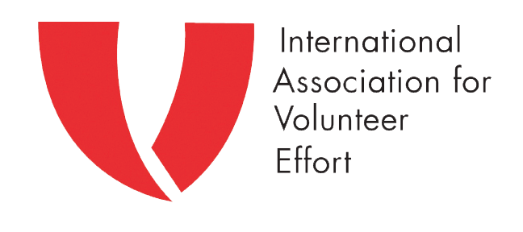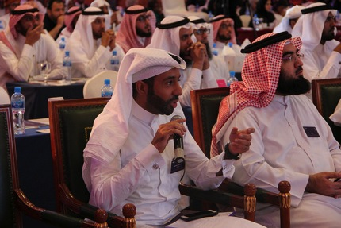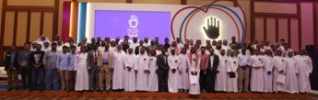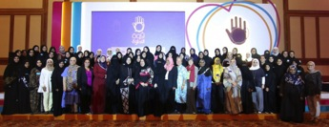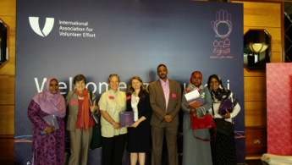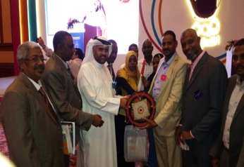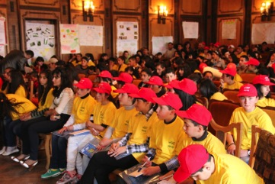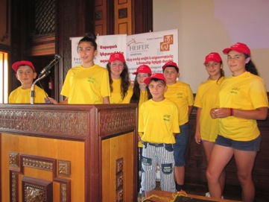

It was while celebrating the contribution of volunteers and role of volunteering at the 3rd IAVE Arab Nations Regional Conference in Bahrain that news reached us of the devastating and deadly terrorist attacks in Beirut and Paris.

In a notable year for volunteering in which the role of volunteers was recognised by the United Nations (UN) in 2030 Sustainable Development Agenda and in which the UN General Assembly passed a resolution on “Integrating volunteering into peace and development: the plan of action for the next decade and beyond” the terrorist attacks highlight that the role of volunteering in contributing to a more peaceful world is more essential than ever.

When Parisians went on Twitter after the attacks with the hash tag #PorteOverute (open doors) offering their homes and businesses to anyone needing shelter and taxi drivers were reported to be transporting people for free as the public transport system was shut down it highlighted that people who want to help will always find ways to volunteer when others in crisis need support.

However questions for us all as leaders in volunteering to consider is how the fear of terrorism, and government and community reaction to it, and responses intended to offer protection for citizens such as increased vigilance and security checks have the potential to impact on *if, when and how* people volunteer in the longer term.

What role would extended lock-downs of a city have on the free movement of people to volunteer? How is the right to peaceful protest on genuine issues of community and global concern affected? How would the need to ‘stay inside’ or ‘keep away from public places’ impact on those who are already isolated or vulnerable? Will community trust be weakened in the longer term?

These are not easy questions to answer, and almost certainly the answers that we might arrive at will not be clear cut, but they *are* questions I propose that leaders in volunteering will need to engage with as we continue to promote, support and celebrate volunteering in all of the myriad ways it happens throughout the world.

**Viva la Volunteering**By **Kylee Bates**, IAVE World President

**Table of Content**

* Viva la Volunteering
* A Successful 3rd Arab Nations Regional Volunteer Conference
* A Brief Report on the Bahrain Conference
* The UN Resolution: Implementing Volunteering in the Post-2015 Agenda
* YES! Youth Clubs Hold an Annual Forum in Armenia
* Benefits of Encouraging Youth Volunteering
* 10th Anniversary of Hong Kong Council of Volunteering Pays Tribute to Professional and Senior Executive Volunteers
* Happy International Volunteer Day
* Thank You from the World President

December 2015

**E-IAVE**

Volunteer leaders throughout the Arab Nations region convened this November for the 3rd Arab Nations Regional Volunteer Conference in Manama, Bahrain. This year’s conference highlighted the power of volunteering, with five main themes of discussion.

The conference kicked off with an opening ceremony, with a speech from IAVE World President, Kylee Bates. Sheikh Hisham bin Abdulrahman Al Kahlifa, the governor of Manama, was present during the ceremony.

The conference was hosted by 4Shbab Global, an organization headquartered in Bahrain that seeks to empower youth by disseminating and establishing a culture of volunteering and positivity among young people. With the help of dozens of volunteers, 4 Shbab hosted a successful conference, with 40+ presenters and panelists.

To learn more about the conference please read IAVE Arab Nations Regional Representative, Osama Mustafa Suliman’s report on the conference below. An online report will also be made available soon. Stay tuned to find out more.

A Successful 3rd Arab Nations

Regional Volunteer Conference

Manama, Bahrain

November 12-14, 2015

## There were more than 250 participants at the 3rd Arab Nations Regional Volunteer Conference in Bahrain. Participants came from all over the Arab region, including but not limited to: Bahrain Kuwait, Oman, Jordan, Qatar, Saudi Arabia, Lebanon, Libya, United Arab Emirates, and Sudan. IAVE National Representatives were also present during the conference.

## The opening ceremony of the conference was attended by His Highness Sheikh Hisham bin Abdulrahman Al Khalifa, governor of the capital city.

**The main objectives of Conference:**

* To highlight volunteer activity efforts in the Arab world.
* To network and form links for cooperation between institutions and organizations and those interested in volunteer work.
* To benefit from the expertise of other volunteer leaders and to follow examples of existing global programs, so it can be implemented in the Arab region.
* To improve awareness of volunteering.

**Themes of the conference:**

* Sustainability of volunteer work on individual and nation levels
* Measuring the impact of volunteer work
* Volunteer management for individuals and institutions
* The definition of social leadership and its importance
* Volunteer work with corporations

A Brief Report on the Bahrain Conference

By Eng. Osama Mustafa Suliman, IAVE Regional Representative, Arab Nations

The conference sessions and panel discussions spanned for 3 consecutive days, with more than 40 papers presented. All the presenters highlighted the importance of volunteering in all its various forms, and offered their experiences and expertise on volunteering.

**Some of the participants at the conference have recommended the following to be implemented in the Arab region:**

1. Proposal to host the next regional conference in one of the Arab countries in Africa.

2. To develop a database for volunteers in each country in the region, with information regarding volunteer activities

3. To connect volunteer networks to exchange their expertise and experiences.

4. To strengthen media attention on volunteering in the Arab Nations.

5. To better document volunteer experiences in the region.

Approximately 180 young participants visited Tsakhkadzor on July 16-19, 2015 to participate in the annual YES! Rural Youth Clubs Forum. The Forum provides a great opportunity for brilliant youths from different regions of Armenia to meet, share experiences, make new friends and recap their greatest accomplishments during the previous year.

29 YES (Youth Empowering for Self-reliance) Youth Clubs are established in rural communities of Armenia to empower disadvantaged rural youths. Started in 2003 through cooperation between the NGOs Development Principles and Heifer International Armenia, it is primarily directed towards developing skills in search of finding solutions to community development challenges concerning economics, health, education and social life.

The main topic during the first day of the Forum was "How is your YES! Youth Club engaged in decision making regarding the socioeconomic life within your community?"

Each YES club made special presentations on the topic, highlighting their work and achievements over the past year. Overall, the youths realized their need to be proactive to ensure active participation of decision makers in their communities.

Training on advanced approaches in contemporary farm management and presentation on "Smart Farm Management System," was conducted during the second day of the Forum. The rural youth learned about the latest developments in the IT sector directed at advancing farm management via information technologies.

The final session was devoted to the Pan-Armenian Declaration on the 100th Anniversary of the Armenian Genocide. This was followed by the award ceremony for the winners of the essay contest devoted to the Armenian Genocide centennial.

The forum enabled thousands of young people to become part of YES! Youth Clubs’ big family, which enables them to turn their best ideas into reality and develop a strong and sustainable civil society.

YES! Youth Clubs Hold an Annual Forum in Armenia

By Adrine Shirinyan, IAVE National Representative, Armenia

During the 70th session of the UN General Assembly, the UN Resolution “[**Integrating volunteering into peace and development: the plan of action for the next decade and beyond**](http://iave.us5.list-manage.com/track/click?u=507743be4721233a999c89020&id=8806f37eee&e=0ff3e82919)” was adopted, co-sponsored by 100 Member States. The Resolution recognizes that volunteerism can be a powerful means of implementation for the 2030 Sustainable Development Agenda.

Welcoming the integration of volunteerism in the 2030 agenda and in related key documents, Member States acknowledge the multi-stakeholder engagement at global and national level in the lead-up to the post-2015 Summit. For the first time, volunteer-involving organizations are explicitly mentioned in a UN Resolution. IAVE is pleased to one of the two organizations to be explicitly mentioned in a UN Resolution! The resolution acknowledges the contributions made by organizations like IAVE at the local, national, regional and global level. This is not only a great accomplishment for our organization, but also for our networks and our members, like you. Congratulations!

#### **The UN Resolution: Implementing Volunteering in the Post-2015 Agenda**

Benefits of Encouraging Youth Volunteering

By Emilio Guerra Díaz, Director, Alianza Mexicana de Voluntariado, IAVE Member

Involving children in volunteering activities is a great opportunity to encourage generosity, civility, and citizenship. However, those who invite children to volunteer need to take several precautions and be very clear on the purpose of the call to volunteer, especially in countries where there are no legal frameworks to protect volunteers.

The main challenge is to avoid suspicions regarding youths performing voluntary unpaid work and have it misinterpreted as child exploitation.

In Mexico, the Mexican Alliance for Volunteer considers it essential to give a formative character volunteering for youths who are not of legal adult age, which is 18 in Mexico.

Volunteering activities can help children and teenagers discover their vocation at an early age. They can begin to build their profiles with their volunteer activities that help them choose and obtain jobs in the future.

**Some benefits of youth volunteering are:**

* Fostering an attitude of service, consideration of others and responsibility, and promoting integration into the community at a young age
* Instilling a love and sense of responsibility in preserving nature, its many ecosystems and rich biodiversity, and understanding its importance to the foundation of humanity.
* Participants are from various social backgrounds, which promote and encourage principles of tolerance and understanding of cultural diversity.
* The sooner you involve children in volunteering, the deeper the positive impact it has on the development of their social skills, enhancing their understanding of the value of volunteering, which will persist for the rest of their lives.
* It stimulates their imagination and drive for social change in the community, turning them into leaders.
* It makes a positive impact on family integration and gets parents involved in volunteering and its values.
* The collective effort and investment made by the volunteers in preserving, promoting and maintain the community, allows them to generate a positive sense of ownership of their surroundings and to value public assets.

In Mexico, youth volunteering is becoming increasingly relevant. So much so that it is possible in the near future to open a special category in the National Award for Voluntary Action and Solidarity for children, to recognize young volunteers and their efforts.

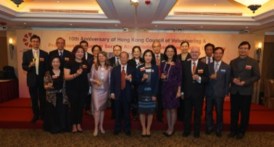 Macintosh HD:Users:jeshkahahn:Desktop:Screen Shot 2015-12-03 at 1.56.52 PM.pngMacintosh HD:Users:jeshkahahn:Desktop:Screen Shot 2015-12-03 at 1.56.40 PM.pngMacintosh HD:Users:jeshkahahn:Desktop:Untitled.pngMacintosh HD:Users:jeshkahahn:Library:Containers:com.apple.mail:Data:Library:Mail Downloads:F91B24D9-5907-4BAC-9C68-BF1F1630982A:Copia  de DSC09139.JPGMacintosh HD:Users:jeshkahahn:Library:Containers:com.apple.mail:Data:Library:Mail Downloads:3851FCFE-0CF3-4780-8305-6A74E5DE1EA8:IMG_2320.JPG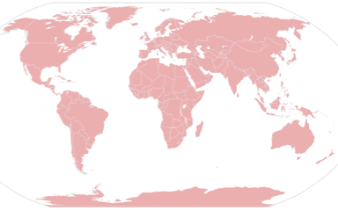

This year marks the 10th Anniversary of the Hong Kong Council of Volunteering (HKCOV). As part of the celebrations, the Professional Volunteer Service Accreditation (PVSA) Joint Presentation Ceremony was held with a cocktail reception on 19 October 2015.

HKCOV is a joint associations’ committee established in 2004 by the Agency for Volunteer Service (AVS) in collaboration with organisations from different sectors. Currently comprising 16 member organizations, HKCOV provides a platform for exchange and collaboration to cultivate broadened participation in volunteering.

To recognize and encourage more professionals and senior executive to volunteer, HKCOV initiated the PVSA Program together with AVS and its member organizations in 2005. Over the years, Association of Hong Kong Nursing Staff, International Chamber of Commerce – Hong Kong, Hong Kong Dental Association, The Hong Kong Institute of Architects, The Hong Kong Institute of Planners, The Hong Kong Institute of Surveyors, The Hong Kong Institution of Engineers and The Law Society of Hong Kong have implemented the Program to commend their dedicated and active members contributing professional skills to serve the community. Those who have offered distinguished volunteer service in the PVSA Program will be selected and conferred the “Leadership Bauhinia (LB) Volunteer Award” by AVS.

PVSA Joint Presentation Ceremony was held on 19 October 2015, officiated during HKCOV’s 10th anniversary. Ms. Kylee Bates, World President of International Association for Volunteer Effort and Mrs. Betty Fung, Permanent Secretary for Home Affairs presented certificates to more than 100 professionals and senior executives from HKCOV member organizations implementing the PVSA Program.

At the ceremony, Ms. Bates commended the PVSA Program, stating that it was a positive approach in promoting skilled volunteering, to help those in need, and contributed to make the community better, stronger and more resilient. Mrs. Fung appreciated the contributions of volunteers from a wide range of professions, and congratulated all PVSA awardees for their dedication and sterling contributions.

Mr. J. P. Lee, Chairman of HKCOV shared that professional and executives have grown to become a significant volunteer force. According to the survey conducted by AVS in partnership with the University of Hong Kong in 2009, professionals and managers accounted for 49% of current volunteers who were gainfully employed. HKCOV is pleased to see such trend and thankful for the effort of member organizations’ to promote the volunteering spirit and building the community.

**Member organization includes:**

|  |  |
| --- | --- |
| Agency for Volunteer Service | The Hong Kong Institute of Architects |
| Association of Hong Kong Nursing Staff | Hong Kong Institute of Certified Public Accountants |
| Catholic Diocese of Hong Kong | The Hong Kong Institute of Landscape Architects |
| Committee on Home-School Cooperation | The Hong Kong Institute of Planners |
| Hong Kong Sheng Kung Hui | The Hong Kong Institute of Surveyors |
| Hong Kong Subsidized Secondary Schools Council | The Hong Kong Institution of Engineers |
| International Chamber of Commerce – Hong Kong | The Hong Kong Medical Association |
| Hong Kong Dental Association | The Law Society of Hong Kong |

#### **10th Anniversary of Hong Kong Council of Volunteering Pays Tribute to Professional and Senior Executive Volunteers**

#### By **Flora Chung**, CEO, Agency for Volunteer Service, IAVE National Representative, Hong Kong

International Volunteer Day is this Saturday, December 5th! IVD is a day dedicated to celebrate volunteering in all its facets, paying special tribute to volunteers for contributing to development at the local, national and international levels. First established by the United Nations on December 17, 1985, governments, non-profit organizations, those in the private sector and other stakeholders are invited to celebrate and acknowledge the impact volunteers and their work have made in society.

This year’s International Volunteer Day is especially important as it pays special praise to volunteers working to implement the new Sustainable Development Goals.

IAVE members all around the world are celebrating IVD in a myriad of ways, from organizing service activities to hosting advocacy seminars to further promote volunteering in their respective countries. Read more about their celebrations below!

**Happy International Volunteer Day!**

**VENEZUELA**

Due to the upcoming elections, Venezuela celebrated a month early! View the pictures below:

**COLOMBIA**

In Colombia IVD celebrations will be hosted by FIPAN and will highlight the work of Colombian volunteers, recognizing their efforts. Keynote speakers will also be invited to present.

**ECUADOR**

IAVE NR, ACORVOL, have published and circulated 30,000 copies of a supplement promoting IVD in Ecuador. [**Read it in Spanish here**](https://www.iave.org/iavewp/wp-content/uploads/2015/12/suplemento-ACORVOL-2015.pdf)**.**

**PERU**

IVD celebrations will take place at the Plaza Mayor in Lima, with attendance from volunteers, corporations and government agencies. The celebration will not only call attention to the SDGs, but will also focus on El Niño weather phenomenon, which is currently threatens to bring flooding and drought throughout the country.

**NEW ZEALAND**

VNZ have applied the theme to celebrate the many hands *Transforming Governance*through local, national, and international levels. This theme is also linked to the important role volunteering plays in achieving the UN’s ‘Sustainable Development Goals’.

**TAIWAN**

IAVE Taiwan will be holding seminars titled “Volunteerism and the SDGs” in two universities in North and Central Taiwan. In South Taiwan, a group of youth volunteers will gather in Kaohsiung City where they will promote International Volunteer Day to the public in busy MRT stations. The public will also be requested to join the “2015IVD Selfie” campaign to introduce IVD to their friends on social media.

**KENYA**

The local government in Makueni County is hosting the celebration for International Volunteer Day in Kenya. During the celebration, volunteers will plant over 500 trees in the community with the motto “Greening Makueni County”. The overall national campaign is called “Lead the Change”.

It has been a momentous year for IAVE culminating in a highly productive strategic planning meeting last month and the inclusion of IAVE in the UN Resolution on Volunteerism so as the calendar year draws to a close I would like to thank all of you in the IAVE network for your contributions throughout the year to our work.

Thank you for your participation in our events in Africa, Latin America, Europe, Asia Pacific, North America and the Arab Nations, your attendance at webinars, your E-IAVE articles, your promotion of IAVE whenever you have the chance and critically your support for our ‘Call to Action’ to recognize the importance of volunteers to the achievement of the Sustainable Development Goals as well as your input to our strategic planning process.

I would like to acknowledge the work of the IAVE Secretariat – Kathi Dennis, Kenn Allen, Jessica Han, Ramona Dragomir, Monica Galliano, Raaida Mannaa and Lorrie Foster – for their tremendous efforts to deliver on some significant initiatives this year. They have done IAVE proud. I would like to thank my IAVE board colleagues for their contributions, engagement and leadership. Their passion for, and as, volunteers is formidable.

We expect to share the results of our strategic planning work with you early in 2016, but in the meantime, my very best wishes to you all for a successful, and happy, International Volunteer Day.

**Thank You from the World President**

By **Kylee Bates**, IAVE World President