
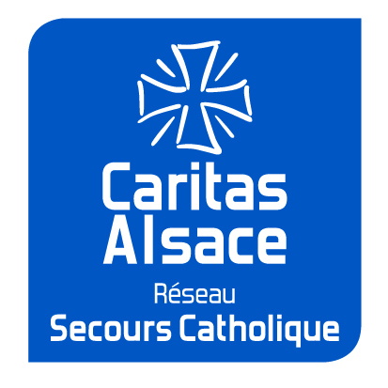




______________________
Strasbourg - 5-8 /10 /2016

Registration Form – Auditor
Please fill in the form in capital letters and send it back to:
Caritas Alsace Réseau Secours Catholique
5 rue Saint Léon - 67082 Strasbourg - France
Tel. : +33 3 88 22 76 40 - Email : euv2016@caritas-alsace.org
PROFILE
Family Name: First Name:
Participate as an auditor at the European University of volunteering 5 to 8 October 2016.
ORGANISATION:
Status in the organisation:
NATIONALITY:
SPOKEN LANGUAGES: ⃝ FRENCH ⃝ GERMAN ⃝ ENGLISH

CONTACT
ADDRESSE:
CITY: POSTAL CODE:
Country:
PHONE:
E-MAIL: @

Inscription Fees
The registration fee covers organizational costs, translation, dinner on Wednesday, 5th October to lunch on Saturday, 8th October, coffee breaks, parties and cultural activities and transport tickets to Strasbourg. Accommodation supplement, see below.
- 220 € for organisational professionals and academics
- 150 € for volunteers and students
ACCOMMODATION
The bedrooms at “Centre culturel Saint Thomas” (2 Rue de la Carpe Haute, 67000 Strasbourg) are reserved during the European University by the organizer Caritas Alsace: www.centre-st-thomas.fr
◻ I wish to stay in the “Centre culturel St Thomas”, provided by the organizers
◻ The night 5th /6th October ◻ The night 6th/7th October ◻ The night 7th /8th October
◻ single room: 50 € per night, breakfast included
◻ twin room: 25 € per night, breakfast included

Rooms will be allocated as a priority to stakeholders and participants, listeners in the order of return of registration. If special arrangements are to be considered on a twin room sharing, please specify:

◻ I will book an accommodation on my own.

MEALS
The lunch and dinner are included in the package. Breakfast is included in the room rate at the Centre St Thomas.
Thank you to specify whether you participate well with meals:
◻ Dinner on Wednesday ◻ Lunch on Thursday ◻ Dinner on Thursday
◻ Lunch on Friday ◻ Dinner on Friday ◻ Lunch on Saturday
If you have specific requests regarding meals (special diets ...), please let us know

Cultural Program
Please specify the dates if you would like to attend cultural programs:
- The evening of opening, Wednesday 5th October, in Centre St Thomas
- The boat evening, on Thursday, 6th October
- The musical evening, on Friday, 7th October, in Münsterhof
- The visit of Strasbourg, on Saturday, 8th October afternoon

VISA
Persons requiring a letter of invitation are invited to us to make the request.
PAYMENT
Registration fees at the University and, if appropriate, accommodation costs, are settled in Alsace Caritas Catholic Relief Network (University co-organizer):
Registration and inscription fee
220 € (or reduced 150 €)
Accommodation:
Number of nights (1, 2 or 3) X price room (50€ or 25€)
TOTAL in €

- By check payable to 'Caritas Alsace - VU' return with your registration form to
Caritas Alsace Réseau Secours Catholique, 5 rue Saint Léon, 67082 STRASBOURG Cedex - FRANCE
- Wire Transfer:
To: Caritas Alsace Réseau Secours Catholique
5 rue Saint Léon – 67082 Strasbourg cedex - France
BIC / SWIFT: CMCIFR2A
IBAN: FR7610278010840007598294505
Reference: Inscription EUV 2016
Please attach a copy of your transfer order to the registration form.
- For cash, on the day, if you do not have another opportunity to advance payment
- You need a bill before to pay your registration fees?

A registration confirmation will be sent by email.
If you do not receive our emails, please contact Caritas Alsace
Phone: +33 3 88 22 76 40; E-mail: euv2016@caritas-alsace.org
Date: / / Signature:

